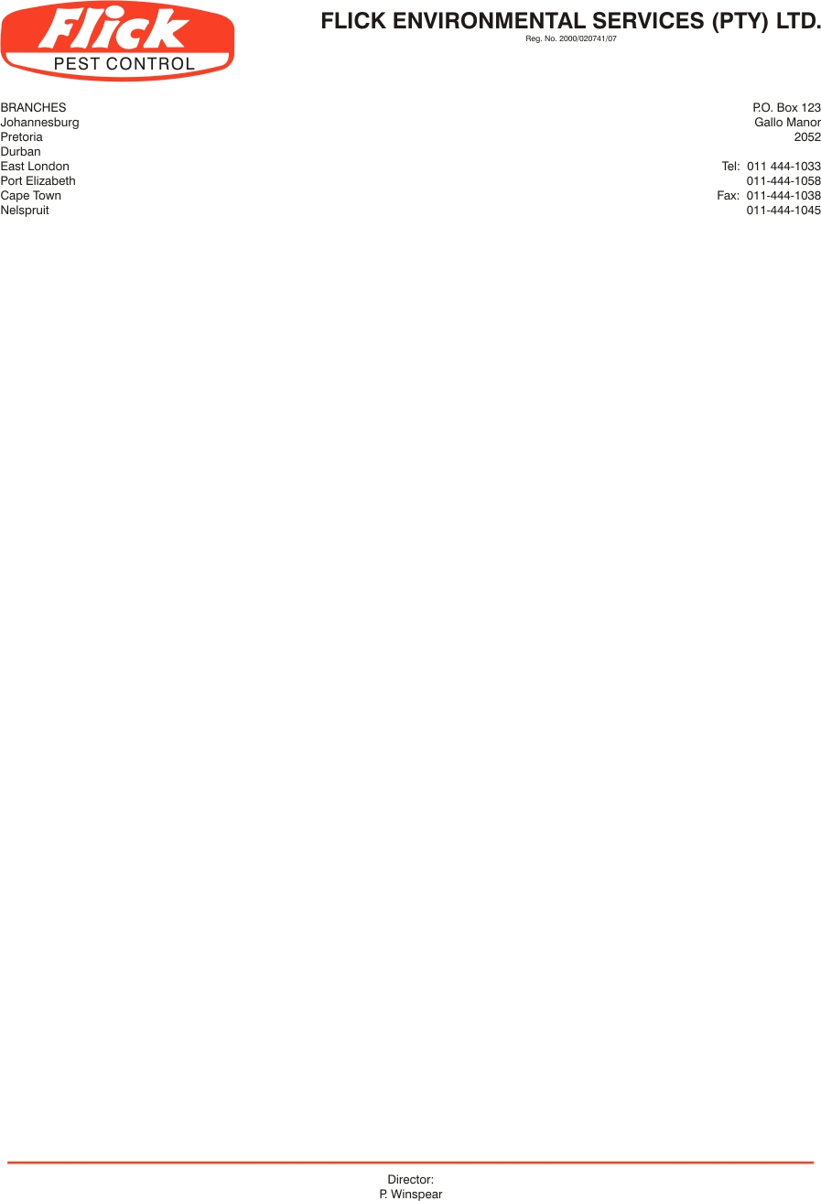
Invoice to: Tia’s

VAT no:

Contact person: Hani Nash 0726143616 / 0117911519 / info@tias.co.za

Service address: Unit 2, Saxon Park, Sterling Road, Strydom Park, Randburg

SERVICE AGREEMENT NO 12427

- FLICK PEST CONTROL agrees to carry out inspections and treatments at the addresses noted above to bring under control any infestation by rats and mice
in the following areas: Service:
10 Rodent bait stations around the outside of the warehouses to be treated on a monthly basis
Bait inside of unit

- FLICK PEST CONTROL agrees to carry out such further inspections and treatments as may be necessary to maintain control of these pests on these premises. Services will be done on a monthly cycle to maintain control of the above pests. (Minimum of 12 treatments and inspections per annum)

- In the event of re-infestation by specified pests anytime during the life of the agreement, FLICK PEST CONTROL will make additional inspections and treatments as to re-establish control of the pests at no extra charge to the client.

- The client agrees to pay for these services at the rate of R590.00 (Exc. VAT) for the initial service. Thereafter R590.00 (Exc. VAT) monthly. The first payment is due on the commencement of the agreement and the subsequent payments monthly thereafter. This price is subject to inflationary increases which take effect periodically.

- This agreement is binding for two years from this date. Notice in writing is required to terminate the agreement at the end of the fist year, or thereafter 3 months notice.

Signed this 24th day of February 2014

Client signature: ________________________ For Flick: _______________________
Client name: Sanet Haupt

